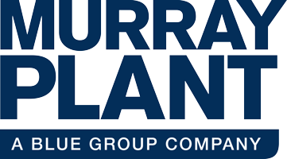

Murray Plant Ltd

SHEQ Info Pack 2023

Valued Customer,

At Murray Plant Ltd, we are committed to continually protecting the safety and health of our employees and interested parties. We strive for the highest standards and are persistently looking at ways we can improve our SHEQ performance.

This pack will provide you with some of our significant SHEQ documentation including policies, insurances accreditations and more.

Many thanks for your custom,

***The Murray Plant Ltd Team***

**9 Craigleith Road**

**Broadleys Business Park**

**Stirling**

**FK7 7LQ**

**Tel: 03330 151 505**



**Useful Contacts**

**Fergal O’Neill, Managing Director- fergal@rammerhammer.co.uk**

**Stephen Stewart, Service Manager-** [**stephen.stewart@bluegroup.co.uk**](mailto:stephen.stewart@bluegroup.co.uk) **07595 161511**

**Rhona McClaren, Office Manager-** [**rhona.mclaren@bluegroup.co.uk**](mailto:rhona.mclaren@bluegroup.co.uk) **03330 151 505**

**Hannah France GradIOSH DipNEBOSH, Group Health and Safety Manager-** [**hannah.france@bluegroup.co.uk**](mailto:hannah.france@bluegroup.co.uk) **07710 167788**

**Our 2023 Objectives:**

**H&S**

* **Identify gaps in training and source appropriate courses**
* **Continue developing our monitoring exercises**
* **Actively encourage employee input on H&S topics**
* **Zero lost time incidents, zero RIDDOR, zero fatalities**
* **Encourage increased reporting of minor incidents and near misses**
* **Prioritise staff wellbeing by introducing various support services**
* **Engage with the wider sector on H&S matters**

**Environment**

* **Provide customers with energy efficient solutions to aid in reducing their carbon footprint**
* **Reduce paper and plastic usage wherever possible**
* **Work with suppliers who are carbon conscious and uphold our same high values and standards**
* **Engage with the wider sector on Environmental matters**



**Insurance Information**



**



Policies- Health & Safety

*full document available upon request



Policies- Environmental

Policies- Quality



Accreditations

Murray Plant are continuously looking to improve SHEQ performance and accreditations, awards and memberships are tangible measures of that. We are proud to be Avetta members and to have been awarded RoSPA Silver award in the past as part of Blue Group. We have plans to add to our accreditations in the near future. Watch this space!

