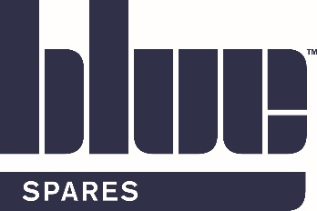
Blue Machinery (Spares) Ltd
SHEQ Info Pack

Valued Customer,
At Blue Machinery (Spares) Ltd, we are committed to continually protecting the safety and health of our employees and interested parties. We strive for the highest standards and are persistently looking at ways we can improve our SHEQ performance.
This pack will provide you with some of our significant SHEQ documentation including policies, insurances, accreditations and more.
Many thanks for your custom,
The Blue Machinery (Spares) Ltd Team
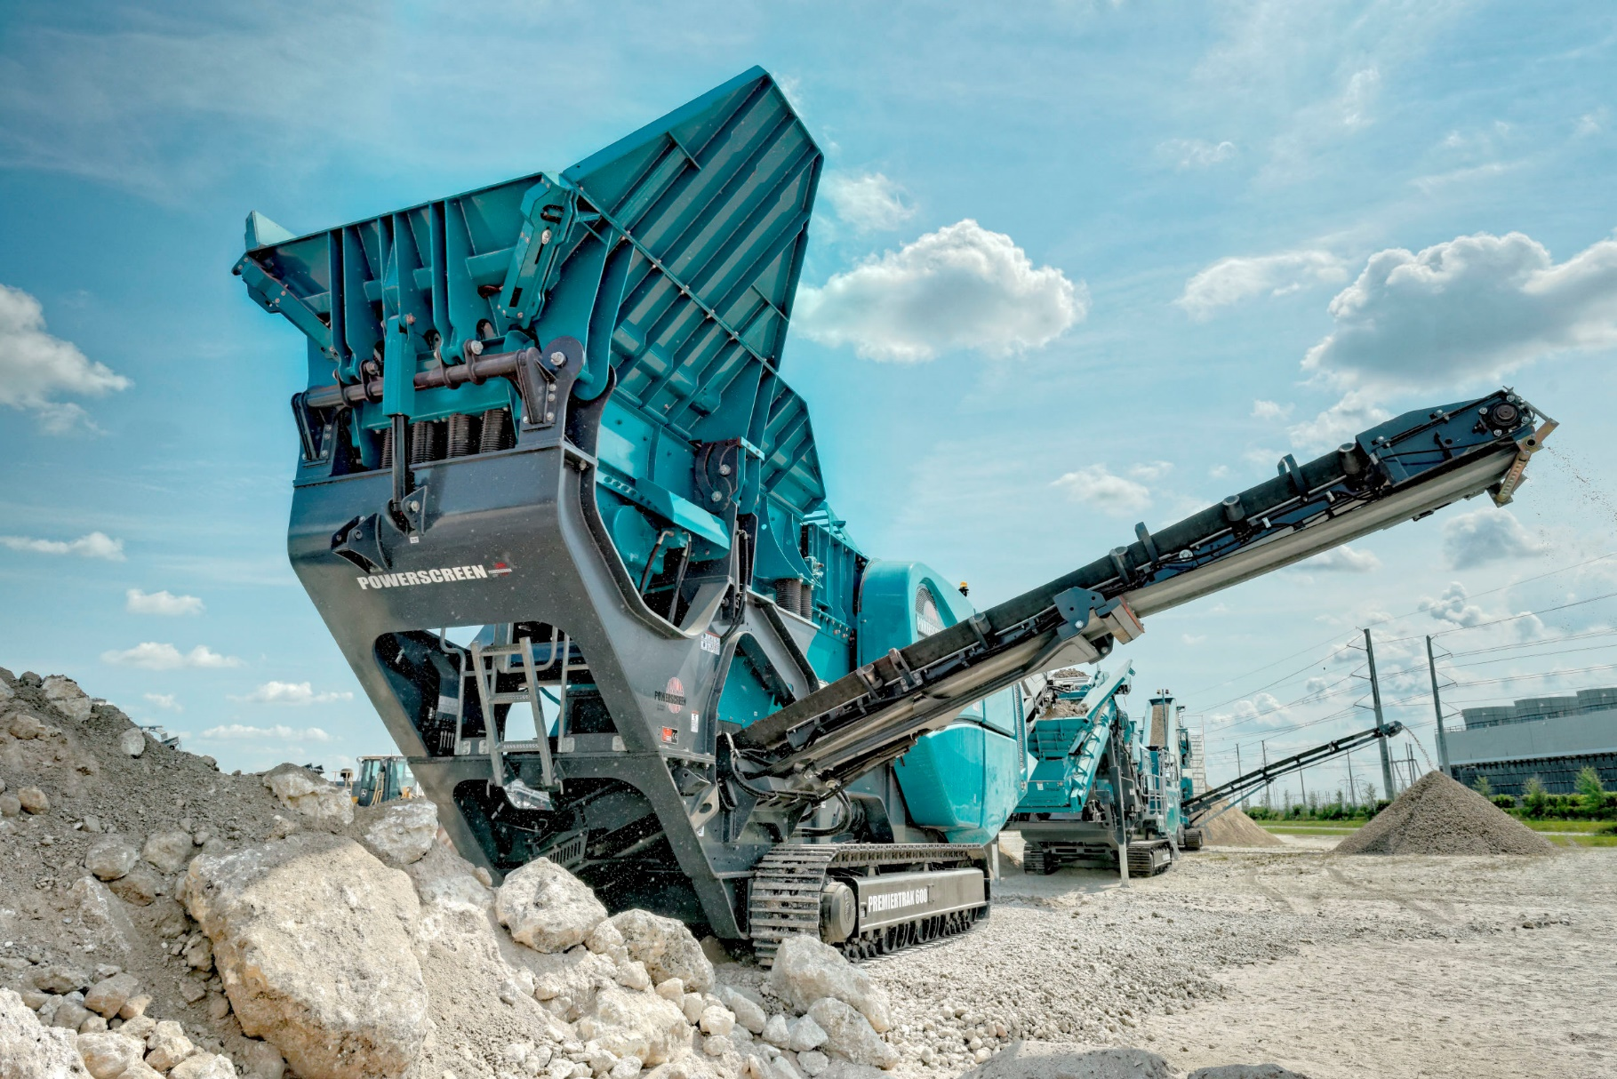
Blue Machinery Spares Ltd Appleton Thorn Trading Estate Warrington Cheshire WA4 4SN T 0345 1300669

Useful Contacts
Ian Webber, Managing Director- ian.webber@bluegroup.co.uk
Chris Thomas, Sales Director- chris.thomas@bluegroup.co.uk
Hannah France TechIOSH, Group Health and Safety Manager- hannah.france@bluegroup.co.uk 07710 167788

Our 2022 Objectives:
H&S
- Continuously identify and address training gaps
- Digitalise H&S Documentation to make it more accessible and easy to use
- Continue to encourage staff input through our Health, Safety and Environmental Committee and other platforms
- Zero RIDDOR reportable incidents and ZERO fatalities
- Support the wellbeing of our staff by introducing further support resources

Environment
- Provide customers with parts solutions which maximise efficiency to aid in reducing their carbon footprint
- Reduce paper usage by digitalising documentation
- Reduce plastic use e.g. by encouraging the use of reusable water bottles
- Ensure waste is recycled wherever possible
- Opt for energy efficient appliances
- Work with suppliers who are carbon conscious and uphold our same high values and standards
- Record our carbon emission figures to compare each year

Insurance Information
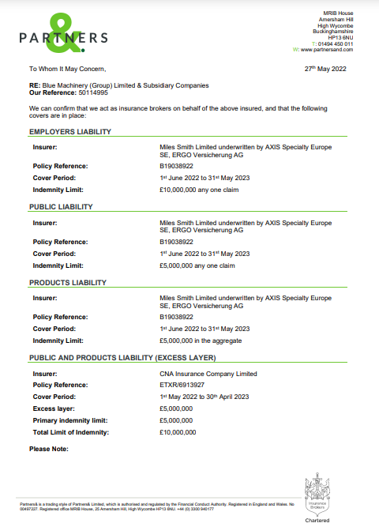

Insurance Information Continued
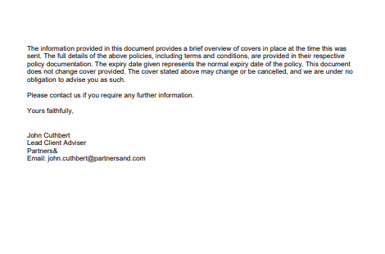

Health & Safety Policy 2022*
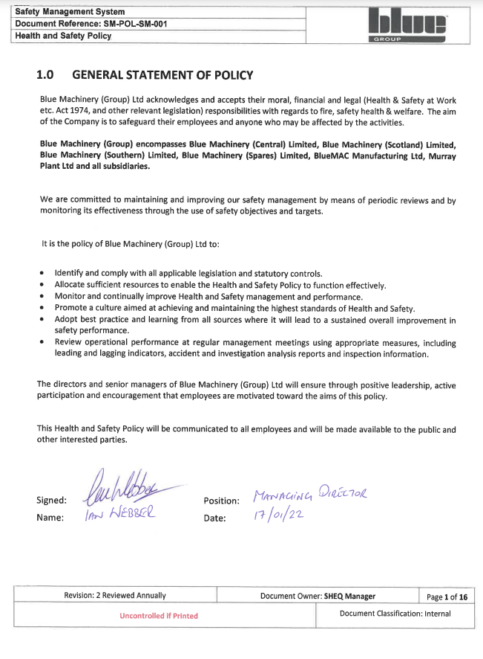

*Full 15 page document is available upon request

Quality Policy 2022
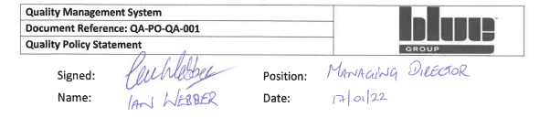
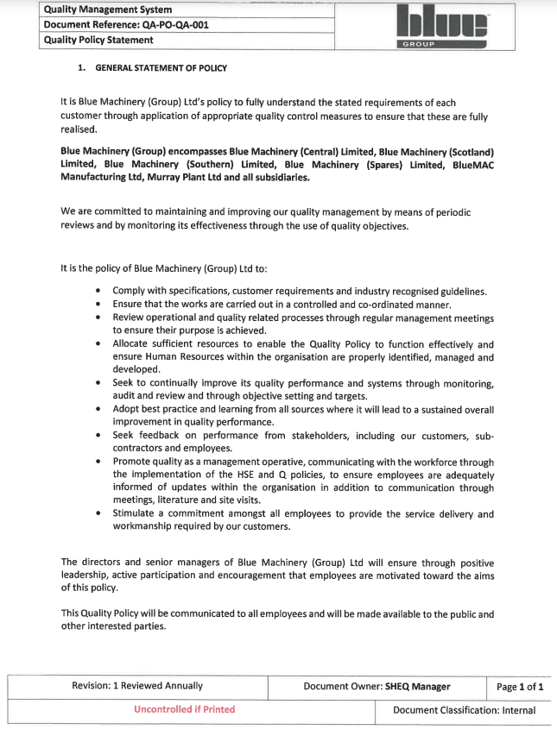
Environmental Policy 2022
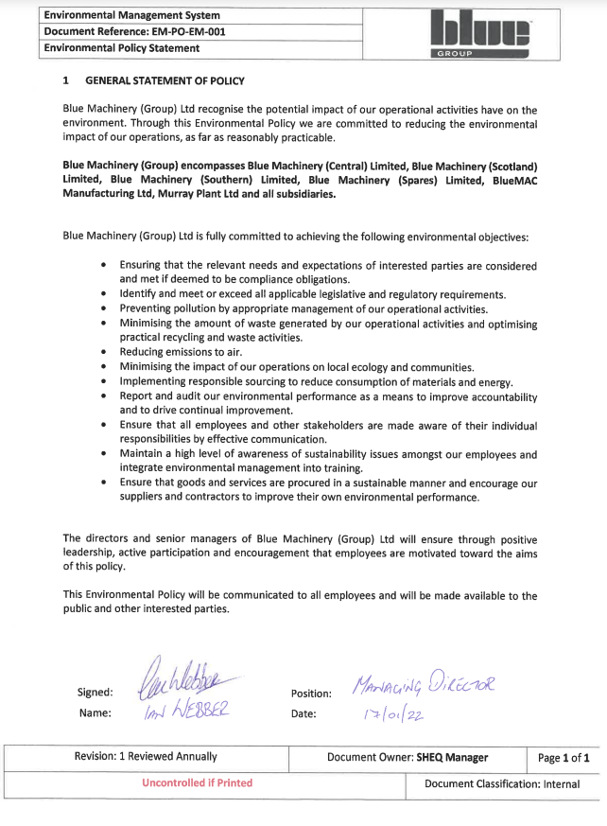

Accreditations
Spares are proud to have achieved the below industry recognised accreditations. Certificates are provided on the subsequent pages. This year, Spares is proud to announce the achievement of the RoSPA Gold Award.
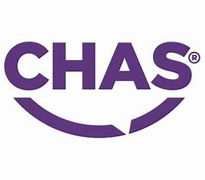
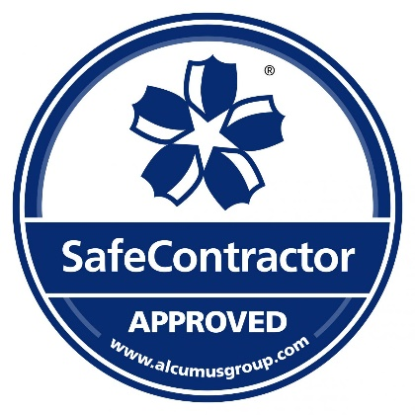
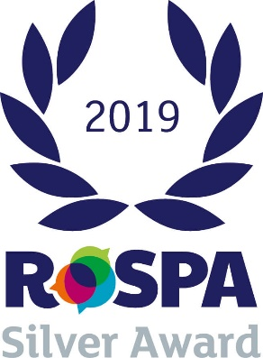
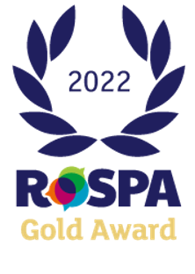
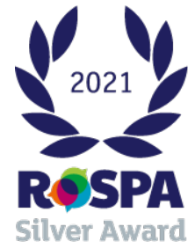

SafeContractor
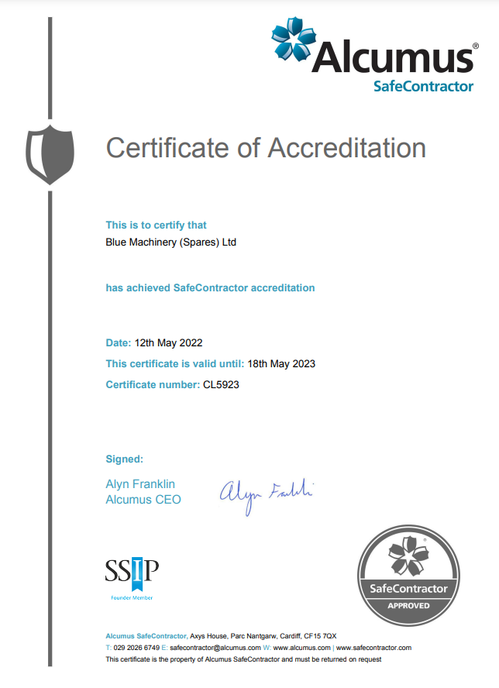

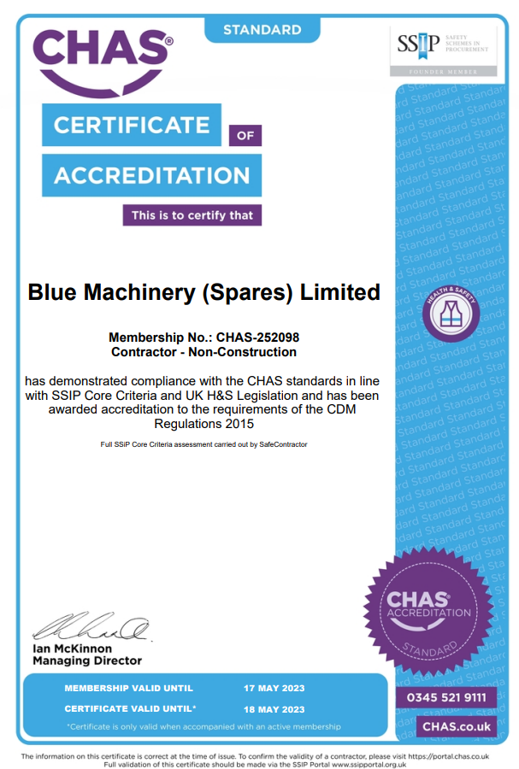
CHAS

RoSPA Gold 2022
(Awaiting certificate)

