Blue Machinery (Southern) Ltd

SHEQ Info Pack

Valued Customer,

At Blue Machinery (Southern) Ltd, we are committed to continually protecting the safety and health of our employees and interested parties. We strive for the highest standards and are persistently looking at ways we can improve our SHEQ performance.

This pack will provide you with some of our significant SHEQ documentation including policies, insurances accreditations and more.

Many thanks for your custom,

***The Blue Machinery (Southern) Ltd Team***

**Useful Contacts**

**Terry Hughes, Managing Director-** [**terry.hughes@bluegroup.co.uk**](mailto:terry.hughes@bluegroup.co.uk)

**Stuart Hardiman, Service Director-** [**stuart.hardiman@bluegroup.co.uk**](mailto:stuart.hardiman@bluegroup.co.uk)

**Hannah France TechIOSH, Group Health and Safety Manager-** [**hannah.france@bluegroup.co.uk**](mailto:hannah.france@bluegroup.co.uk) **07710 167788**

**Our 2022 Objectives:**

**H&S**

* **Utilise new lone working app to protect and monitor lone workers**
* **Continue to identify and address any gaps in training**
* **Make documentation more accessible to remote workers**
* **Actively encourage employee input on H&S topics**
* **Zero RIDDOR reportable incidents, LTIs and fatalities**
* **Retain SafeContractor and CHAS accreditations**

**Environment**

* **Provide customers with energy efficient solutions to aid in reducing their carbon footprint**
* **Reduce paper usage by digitalising documentation**
* **Reduce plastic use e.g. by encouraging the use of reusable water bottles**
* **Work with suppliers who are carbon conscious and uphold our same high values and standards**

**Insurance Information**

**Insurance Information Continued**

Policies- Health & Safety 2022*

*Full document available upon request

Environmental Policy 2022

Quality Policy 2022

Accreditations

Blue Southern are continuously working to improve SHEQ performance. In the last few years we are proud to have achieved recognised accreditations and become members of prominent risk management platforms. We have plans for more SHEQ growth in the near future. Watch this space.

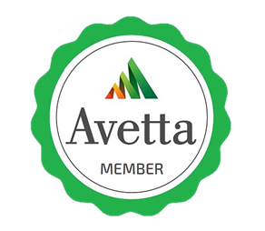

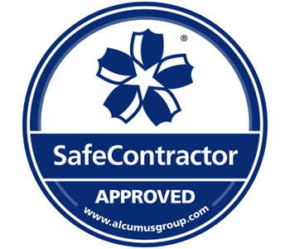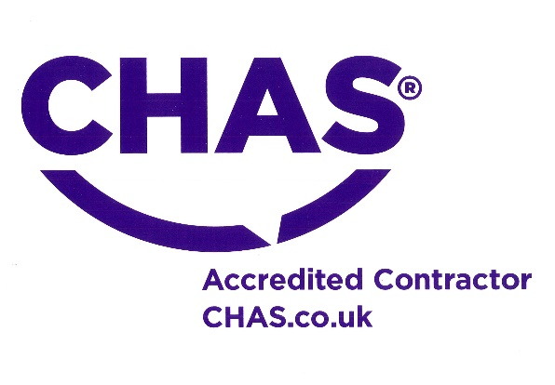

SafeContractor

CHAS

