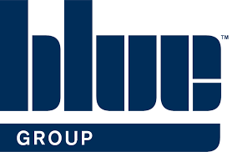
Blue Machinery (Central) Ltd
SHEQ Info Pack
Valued Customer,
At Blue Machinery (Central) Ltd, we are committed to continually protecting the safety and health of our employees and interested parties. We strive for the highest standards and are persistently looking at ways we can improve our SHEQ performance.
This pack will provide you with some of our significant SHEQ documentation including policies, insurances, accreditations and more.
Many thanks for your custom,
The Blue Machinery (Central) Ltd Team Blue Machinery Central Ltd Suite 2 Victoria House New Cheshire Business Park Wincham Lane Northwich CW9 6GG T 01606 261262

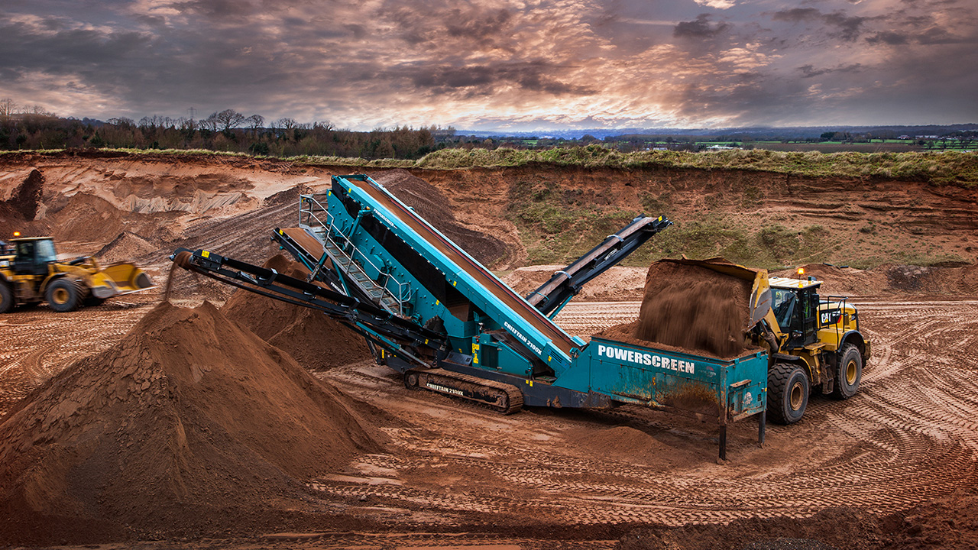

Useful Contacts
Aidan McGeary, Managing Director- aidan.mcgeary@bluegroup.co.uk
Sean McGeary, Sales Director- sean.mcgeary@bluegroup.co.uk
Steve Edwards, After Sales Manager- steve.edwards@bluegroup.co.uk
Rob Davis-Hilliard, Doosan Operations Manager- rob.davishilliard@bluegroup.co.uk
Hannah France TechIOSH, Group Health and Safety Manager- hannah.france@bluegroup.co.uk 07710 167788

Our 2022 Objectives:
H&S
- Make documentation more accessible to all staff including those required to work remotely
- Encourage staff imput through our Health, Safety and Environmental Committee
- Frequently monitor H&S performance of our staff on customer sites
- Zero Fatalities, RIDDOR reportable incidents and lost time incidents
- Retain SafeContractor and CHAS and achive RoSPA Gold
- Introduce support resources to continue to improve staff wellbeing
Environment
- Provide customers with energy efficient machinery solutions to aid in reducing their carbon footprint
- Reduce paper usage by digitalising documentation
- Reduce plastic use e.g. by encouraging the use of reusable water bottles
- Ensure waste is recycled wherever possible
- Work with suppliers who are carbon conscious and uphold our same high values and standards
- Record our carbon emissions annually in order to make more informed decisions on energy usage

Insurance Information
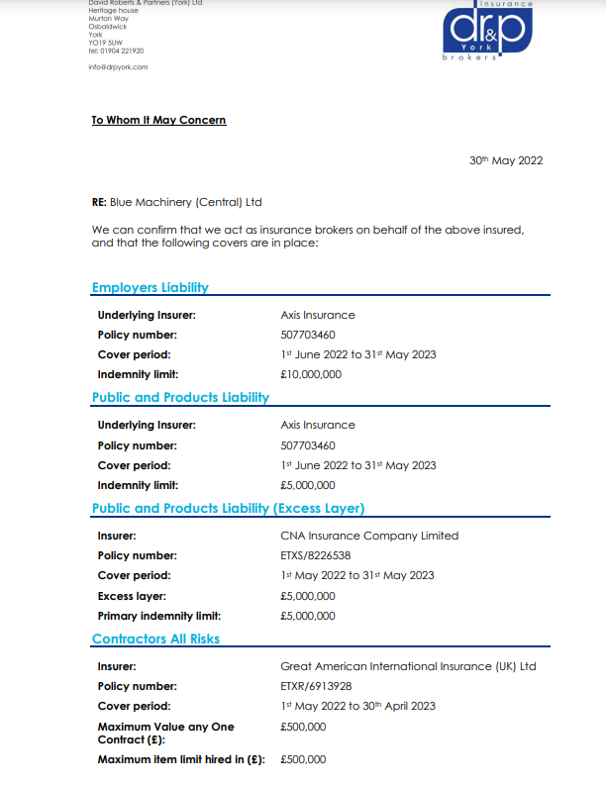

Insurance Information Continued
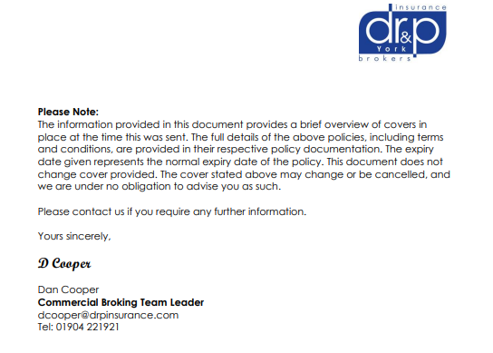

Health & Safety Policy 2022*
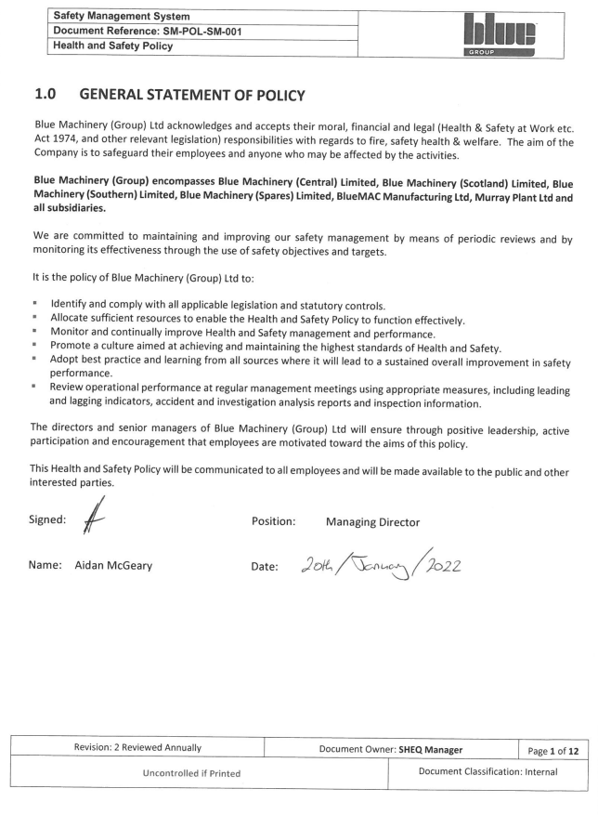

*Full 15 page document is available upon request

Environmental Policy 2022

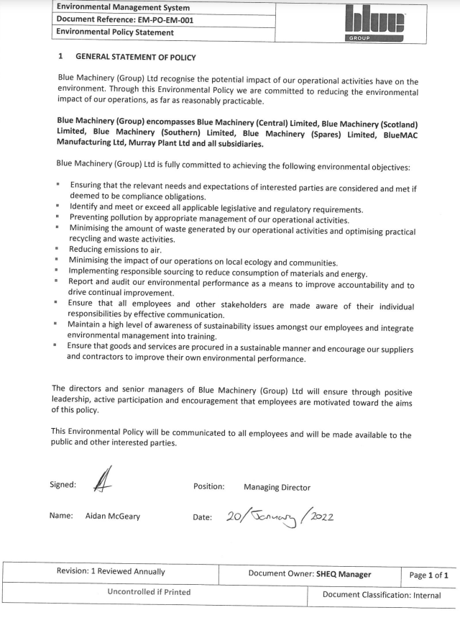

Quality Policy
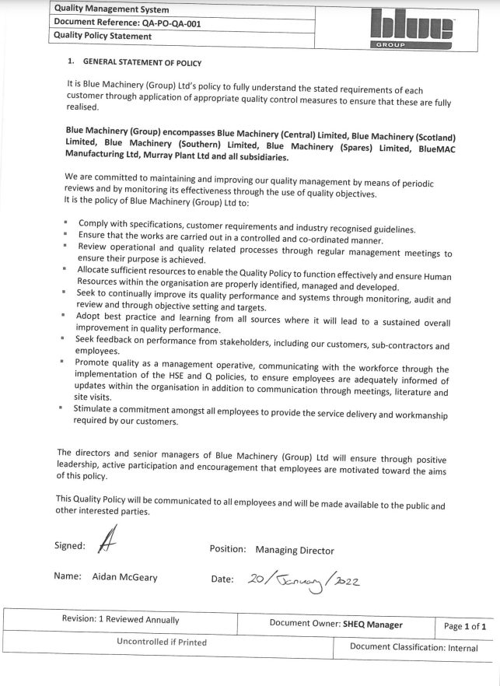

Accreditations
Blue Central have achieved the below industry recognised accreditations. Certificates are provided on the subsequent pages. Central are proud to announce that this year we have successfully achieved the RoSPA Gold Award.
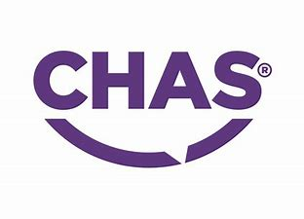
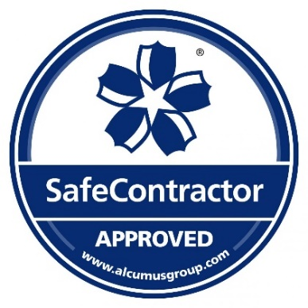
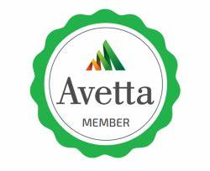

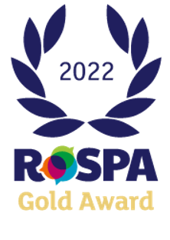

SafeContractor
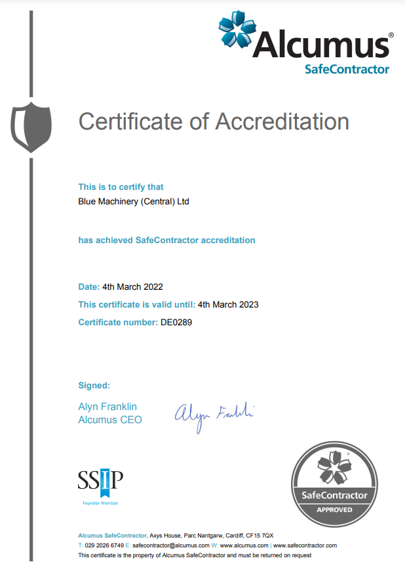

CHAS
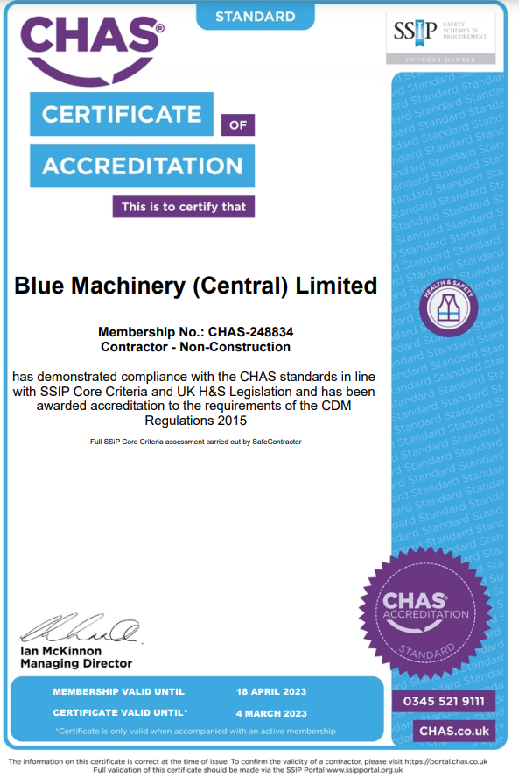

RoSPA Gold
(awaiting certificate)

